 



FLOE NAVIGATION SYSTEM

USER GUIDE

RELEASE 1.0.0

DECEMBER 2018

Nadeem Gul

Rintu Daniel

Contents

Preface: i

Audience: i

Related Documents: i

1. Getting Started 1

2. Dashboard 2

2.1 Status Bar 3

3. Grid 4

3.1 Coordinate System: 4

3.2 Map View 5

3.2.1 Features 6

4. Deployment 13

5. Waypoint 17

6. Sample/Measurement 22

# Preface:

Welcome to the Floe Navigation Android Application. The application can be installed on any Android tablet (For the MOSAiC expedition the tablet being used is [XSLATE D10](https://www.xploretech.com/downloads/Marketing_Brochures/D10/XSLATE_D10_Specsheet_EN.pdf)). This application uses the periodic data from AIS transponders installed on the Sea Ice to create a coordinate system which is fixed on a moving ice floe. It creates a visual representation of the coordinate system in the form of a grid which can be used to navigate on a moving Sea Ice. This guide describes how to use the Floe Navigation Application. It provides instructions for completing common tasks and provides descriptions of the fields, windows, buttons, and menus you will use to perform those tasks. The instructions and descriptions in this guide are based on the default product configuration.

## Audience:

This document is intended for users of the Floe Navigation System application.

Related Documents:

For more information, see the following documents:

* Floe Navigation Administration Guide
* Floe Navigation Developer Guide

# Getting Started

Please read through the following necessary and important configurations that need to be done in the Android environment to ensure the smooth operation of the Floe Navigation App.

* The App needs an AIS Transponder to run. Ensure that the tablet is connected to the Wi-Fi network of an AIS transponder.
* Make sure that only one Tablet is connected to the Wi-Fi network of an AIS Transponder, as the AIS transponders do not support multiple client connections.
* Make sure that the location on the Android device is enabled. For details visit [Android documentation](https://support.google.com/accounts/answer/3467281?hl=en).
* Make sure that the Tablet is not connected to any other network interfaces such as Ethernet/GPRS and only a Wi-Fi network of an AIS Transponder is connected.
* For smooth operation, it is recommended that there are no other apps running on the device when the Floe Navigation App is running.

# Dashboard

The Dashboard is the main screen of the App. It is the first screen that you will see after launching the app. Using the Dashboard, you can navigate to all the sections of the app.

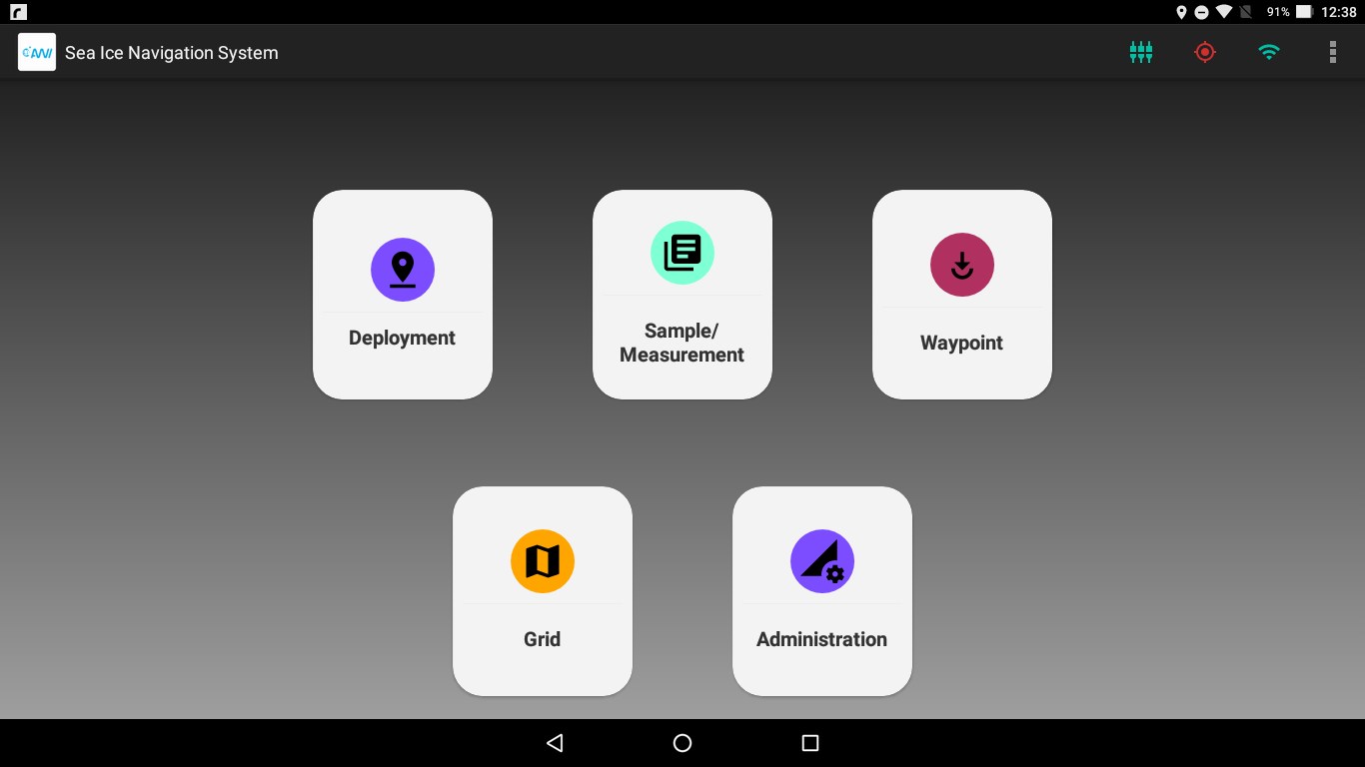

Figure 2.1 Dashboard as seen on Android Tablet

The following icons are visible on the Dashboard:

* **Deployment:** Can be used to deploy a static station. Details in Chapter 4.
* **Sample/Measurement:** To take a Sample/Measurement on the Ice. Details in Chapter 6.
* **Waypoint:** Insert a waypoint on the Grid. Details in Chapter 5.
* **Grid:** Show a visual representation of the whole coordinate system.
* **Administration:** For the administration of the App. Refer to Floe Navigation Administrator Guide.

## Status Bar

The status bar shows important indicators regarding the connectivity and configuration of the app.

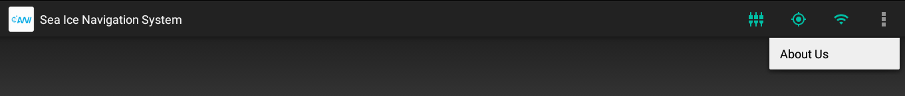

Figure 2.2 Status Bar on Android Device

The icons which are shown in the status bar are:

**Table 2.1 Status Bar Icons**

|  |  |  |
| --- | --- | --- |
| **Icon Name** | **State** | **Description** |
| Grid Setup Complete |  | Green: Grid Setup is complete and the App can be used completely. |
|  | Red: Grid Setup is not completed and you cannot access any functionality of the App. Check Floe Navigation Administration Guide for instructions on configuring the App. |
| Location Available |  | Green: The Device location is available. The App also uses the GPS time to record all the data. |
|  | Red: The device location is not available. Make sure that GPS is enabled. Refer to Chapter 1. |
| Wi-Fi Connection |  | Green: The Device is connected to a Wi-Fi network. |
|  | Red: The device is not connected to a Wi-Fi network. Make sure that Wi-Fi is enabled. Refer to Chapter 1. |
| About Us |  | Shows the About Us Dialog box containing Legal and Developer information. |

# Grid

This chapter describes the Floe Navigation Grid and the coordinate system on which it is established.

## Coordinate System:

The basic aim of the Floe Navigation system is to create a coordinate system which remains static with respect to a moving sea ice. To that end, it uses data from two AIS transponders to set up the coordinate system (For details about AIS see [here](https://en.wikipedia.org/wiki/Automatic_identification_system)). The coordinate system can only be established by an administrator of the system. For details see Floe Navigation Administrator Guide.

The custom coordinate system is created by fixing one AIS transponder as the origin and the other transponder is used to mark the x-Axis of the coordinate system. The y-Axis is then considered as perpendicular to the x-Axis. The custom coordinate system so created moves with the flowing sea ice as the transponders move with it. The positions of the points of interest on the sea ice can then be calculated relative to the custom coordinate system. So that each point of interest on the sea ice will have a {x, y} coordinate pair.



Figure 3.1 Coordinate System Concept at Setup

The Grid is a visual representation of all the above-mentioned coordinate system along with all the points of interests marked on it. The points of interest can be Waypoints, Static Stations (Stations without AIS), Mobile Stations (moving vehicles with AIS) and Fixed Stations (Stations with AIS). The grid also shows the tablet’s current position (own position) on the coordinate system for determining your position on the grid and the position of the mothership.



Figure 3.2 Coordinate System concept with all Points of Interest

## Map View

The Map View is the visual representation of the coordinate system established on the sea ice. The Map View shows all the points of interest that have been installed on the Sea Ice. The Map View shows all the stations and points of interest in a 100 km radius from the origin. There are vertical and horizontal scales on the left side and bottom of the Map View. The scales are in kilometers by default however when zoomed in, it automatically changes the scales to meters.

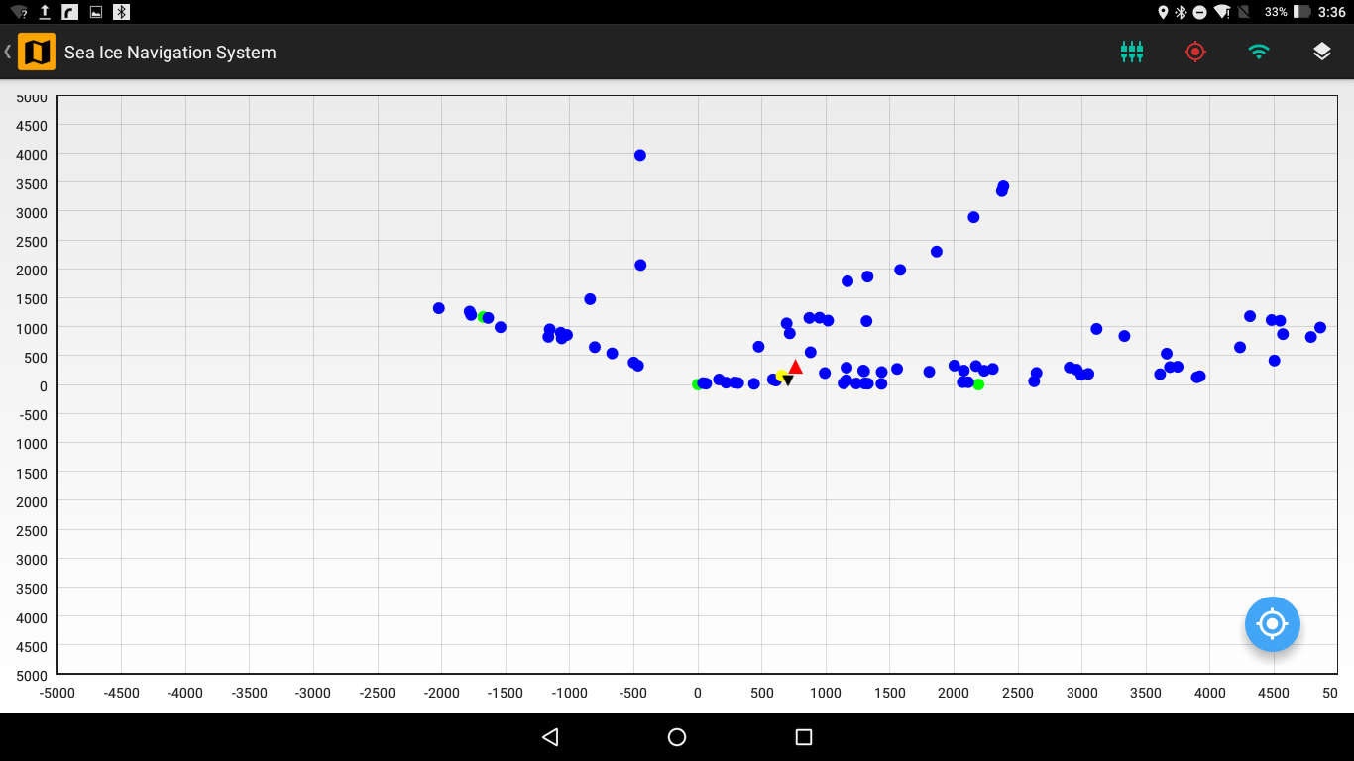

Figure 3.3 Map View of Coordinate System with Points of Interest

### Features

Several sophisticated features are available in the map view to aid you in visualizing the map view of the sea ice.

#### Layers

There are different layers on the Map View and you can set the visibility of each layer. The tablet location is always visible. By default, the visibility of all the layers is set on the Map View.

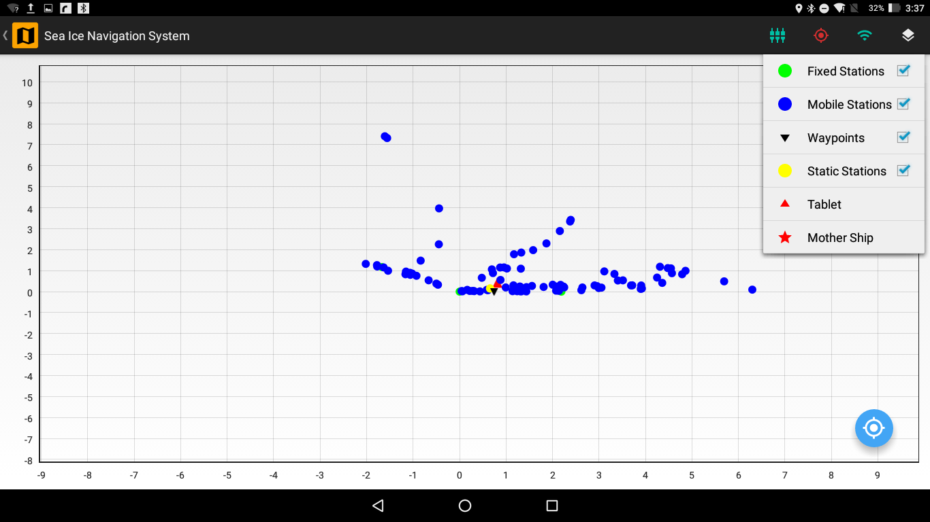

Figure 3.4 Map View with the available layers

The Layers that are visible on the Map View are:

**Table 3.1 Available Layers in Map View**

|  |  |  |
| --- | --- | --- |
| **Layer** | **Icon** | **Description** |
| Fixed Station |  | These are fixed position on the ice where AIS transponders have been mounted. Deployment of such station can only be done by an administrator (refer to Floe Navigation Administrator Guide for details). The periodic AIS data from these stations is used by the App to maintain the coordinate system. |
| Mobile Station |  | These are vehicles which are moving on the Sea Ice and have an AIS transponder mounted on them. The Map View will show all the mobile stations in a 100km radius. |
| Waypoints |  | These are points of interest on the Sea Ice. For details refer to Chapter 5. |
| Static Stations |  | These are fixed position on the ice without an AIS transponder. You can deploy such stations using the Deployment section (For details refer Chapter 4). |
| Own Position |  | This shows your current location on the Map View relative to the custom coordinate system. |
| Mother Ship |  | This is a special type of Mobile Station which shows the position of the Mother Ship. |

The screenshots of the different layers on the Map View are shown below:

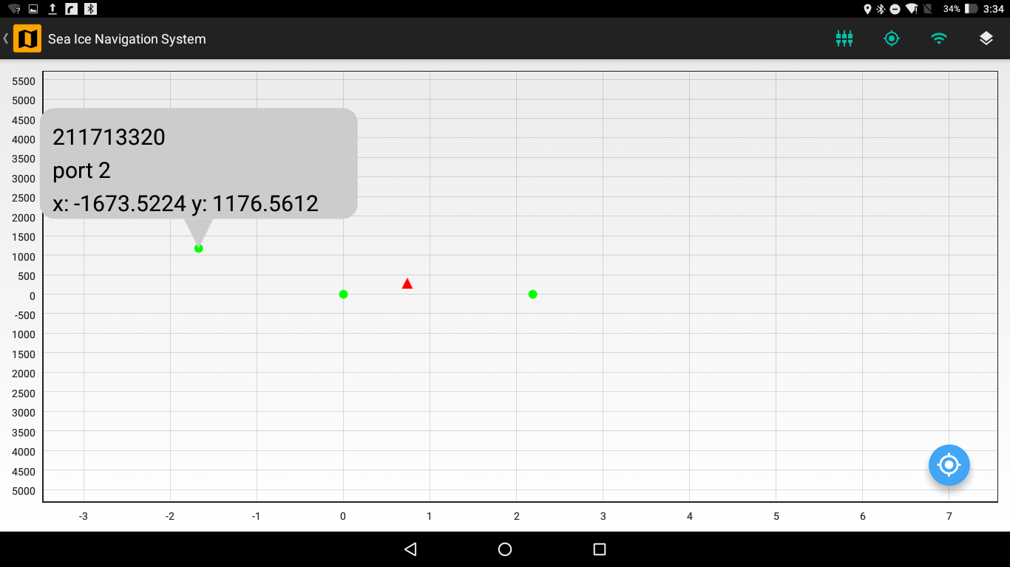

Figure 3.5 Fixed Stations on the Map View

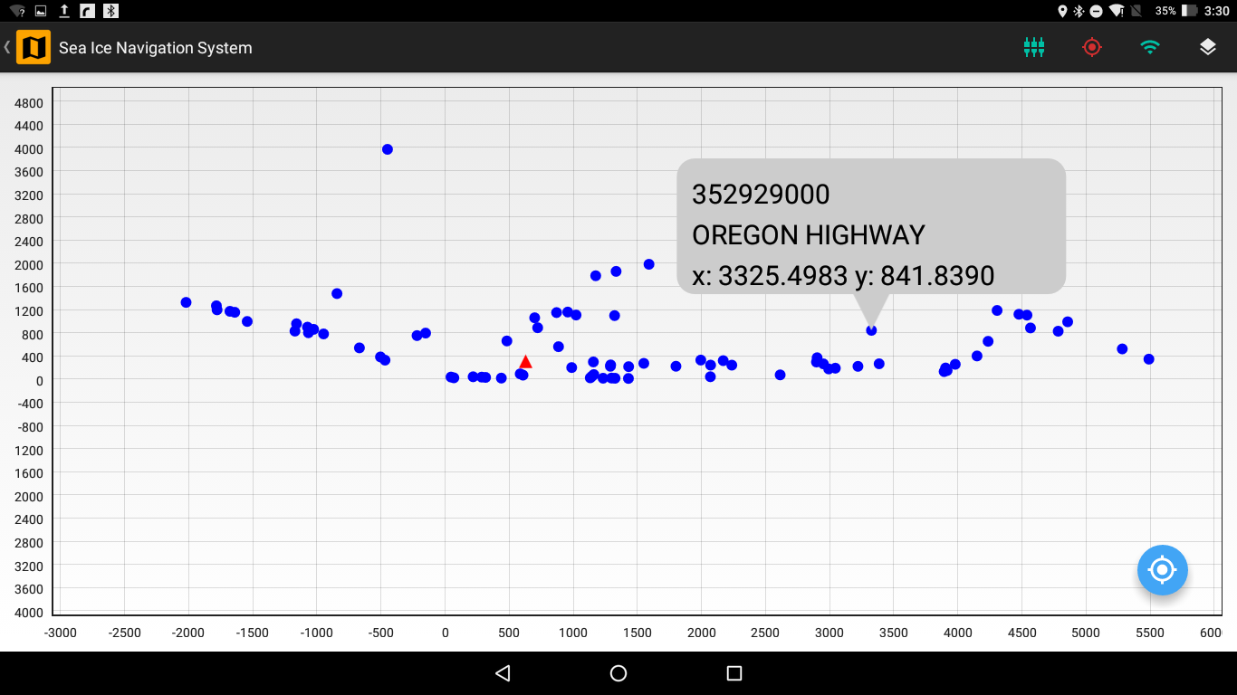

Figure 3.6 Mobile Stations on the Map View

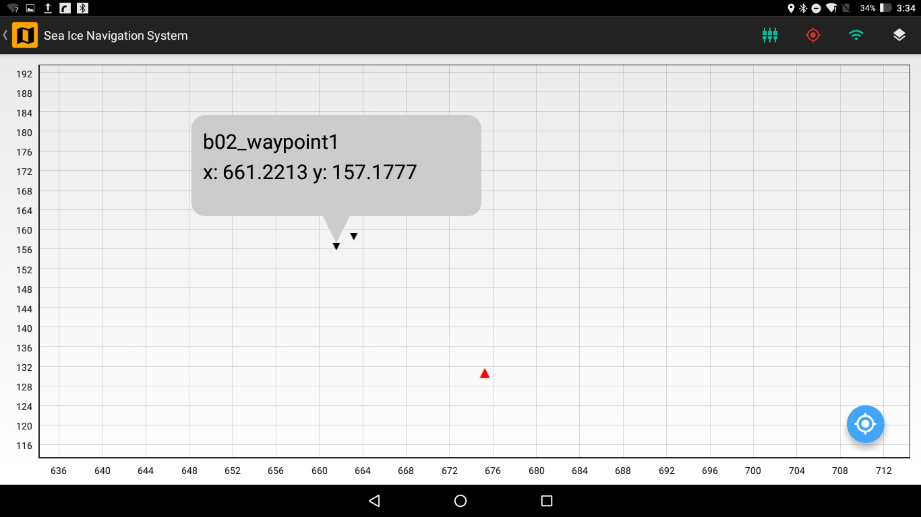

Figure 3.7 Waypoints on the Map View

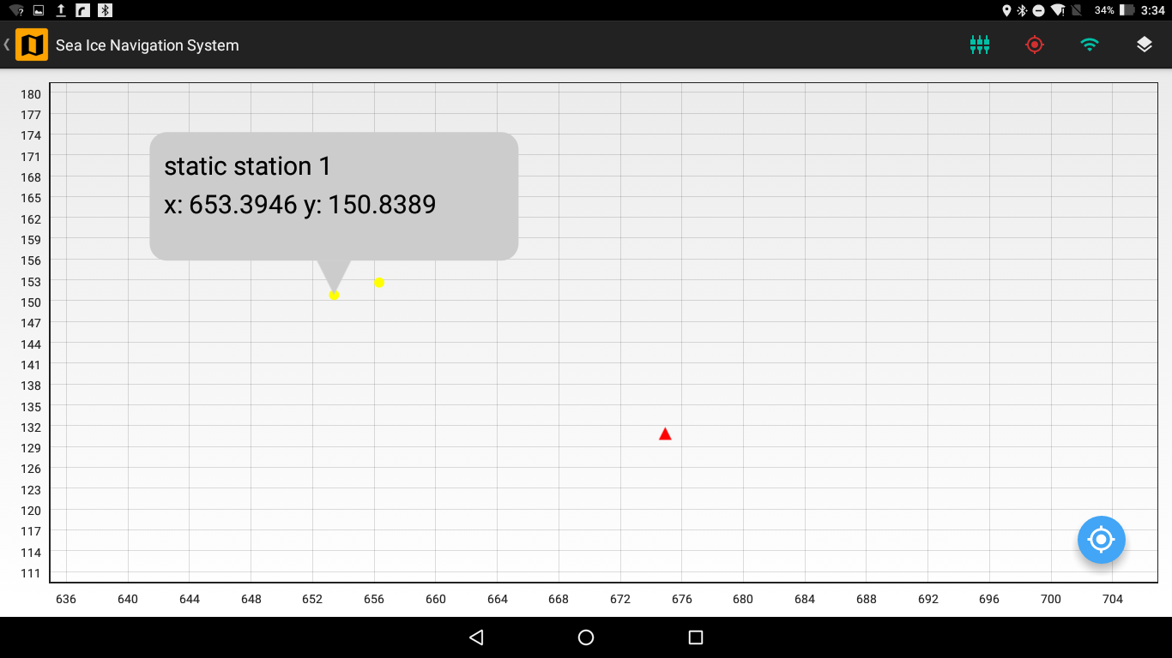

Figure 3.8 Static Stations on the Map View

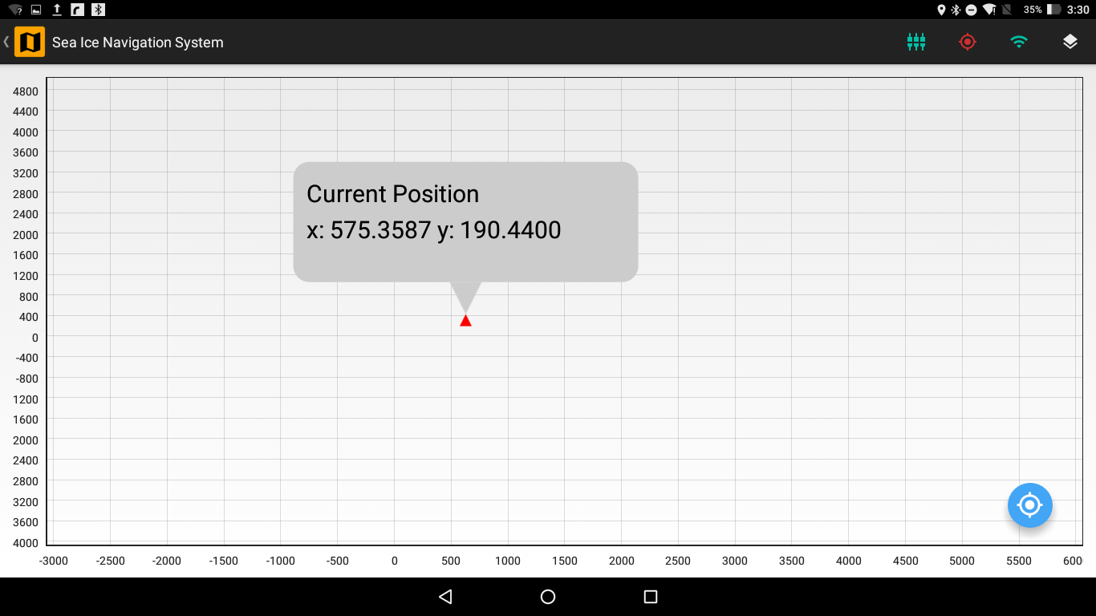

Figure 3.9 Own Position on the Map View

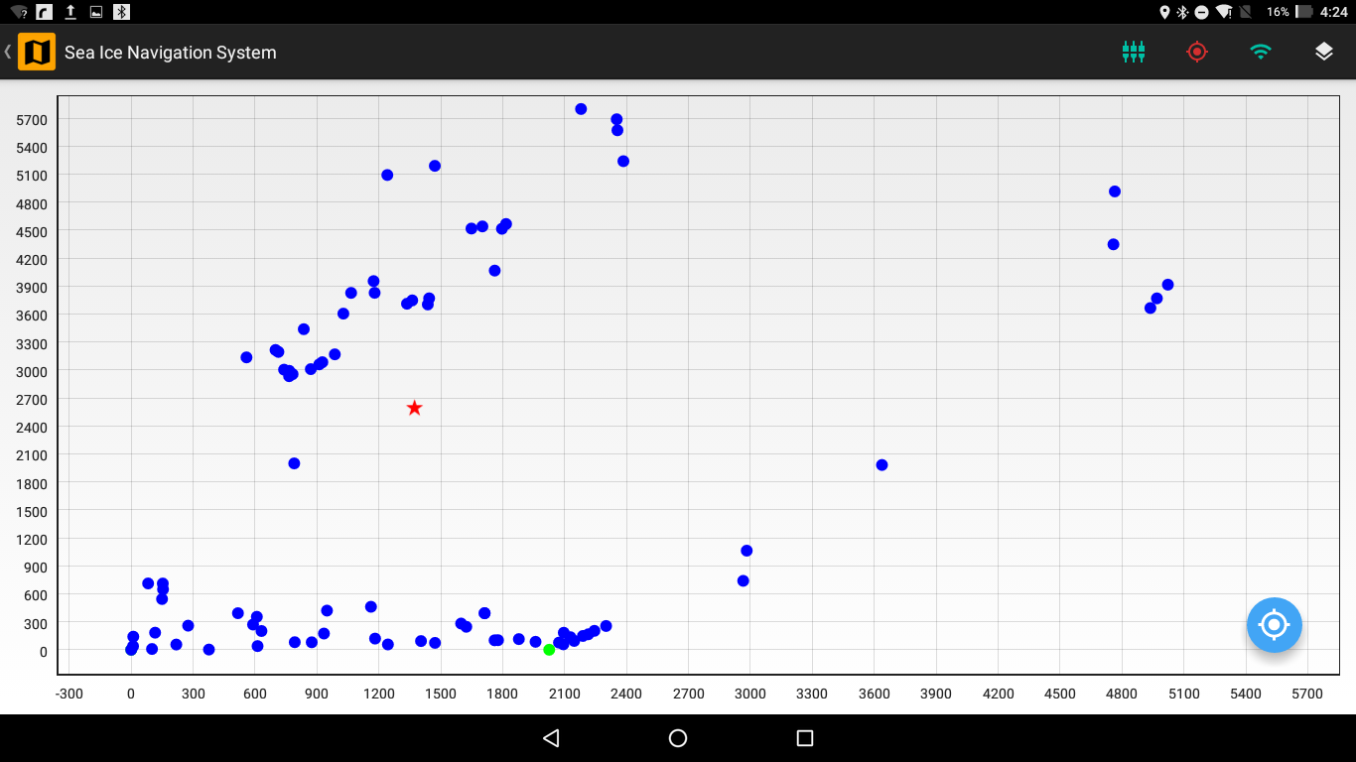

Figure 3.10 Mother Ship on the Map View

#### Details Box

When you tap a station or a point of interest the *Details Box* appear which shows the details of that station or point of interest. The *Details Box* displays the name of station/point of interest if exists, MMSI (only for a station with AIS such as Fixed Stations and Mobile Stations) and {x, y} coordinates of the station/point of interest in meters.

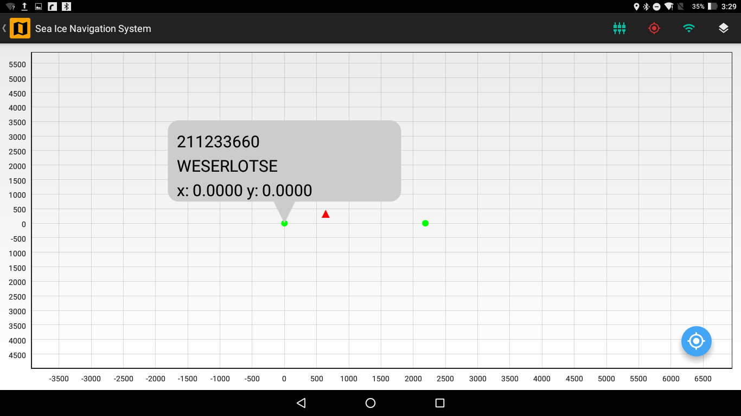

Figure 3.11 Details Box of a Fixed Station on the Map View

#### Zoom & Pan

You can zoom and pan on the map view. So as to locate a specific station/point of interest you can zoom in to the map view and tap that station/point of interest to see its *Details Box*. You can also move the map view when zoomed in using the pan feature.

#### Focus Button

There is a Focus Button on the Map View which will focus the map view either on your location if your location is available via GPS of the tablet or on the origin if GPS location is not available. The map view will be focused on a 5km radius of either your location or the origin.

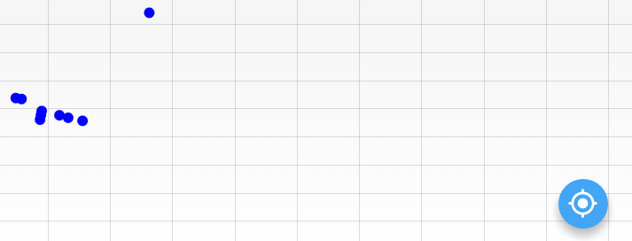

Figure 3.12 Focus Button on the Map View

# Deployment

This Chapter describes the deployment of Static Stations in the Floe Navigation System.

Static Stations are fixed points on the Sea Ice where any equipment or structure has been installed without an AIS Transponder; therefore, these Static Stations are not used by the App to maintain the coordinate system. Each Static Station is identified by a unique name. The Static Station can be of type Tent, Hut, Mast or a Fixpoint. Each Static Station has a {x, y} coordinate pair associated with it.

You can install a new Static Station by tapping on the Deployment button on the Main Dashboard which opens the Deployment screen. Static Stations once installed can only be deleted by an administrator (For details see Floe Navigation Administrator Guide).

You should specify a unique name for each Static Station. The App deploys a static station at the current location of the tablet which is available via GPS. The Deployment screen shows the current location of the tablet in the current Latitude and Longitude fields of the screen. The software is designed in such a way that the latitude and the longitude fields will be automatically updated when you move with the tablet. If the location is not available the current Latitude and Longitude Fields will be set to 0.00.

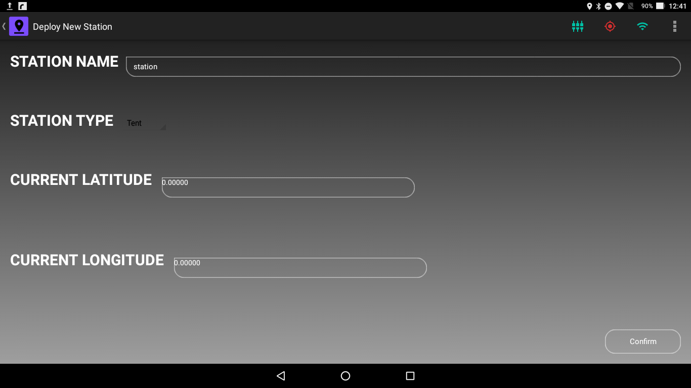

Figure 4.1 Deployment of a Static Station when Tablet location is not available

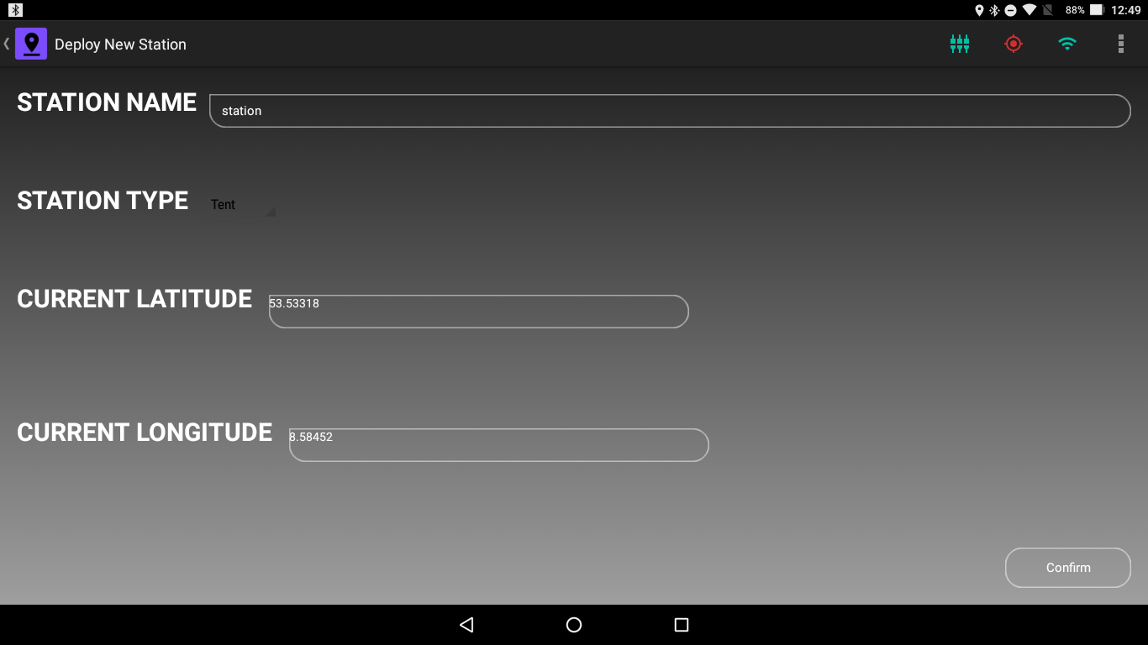

Figure 4.2 Deployment of a new Static Station when Tablet Location is available via GPS

A Change Lat/Lon Format button is available in the Status Bar to change the format of the displayed coordinates.

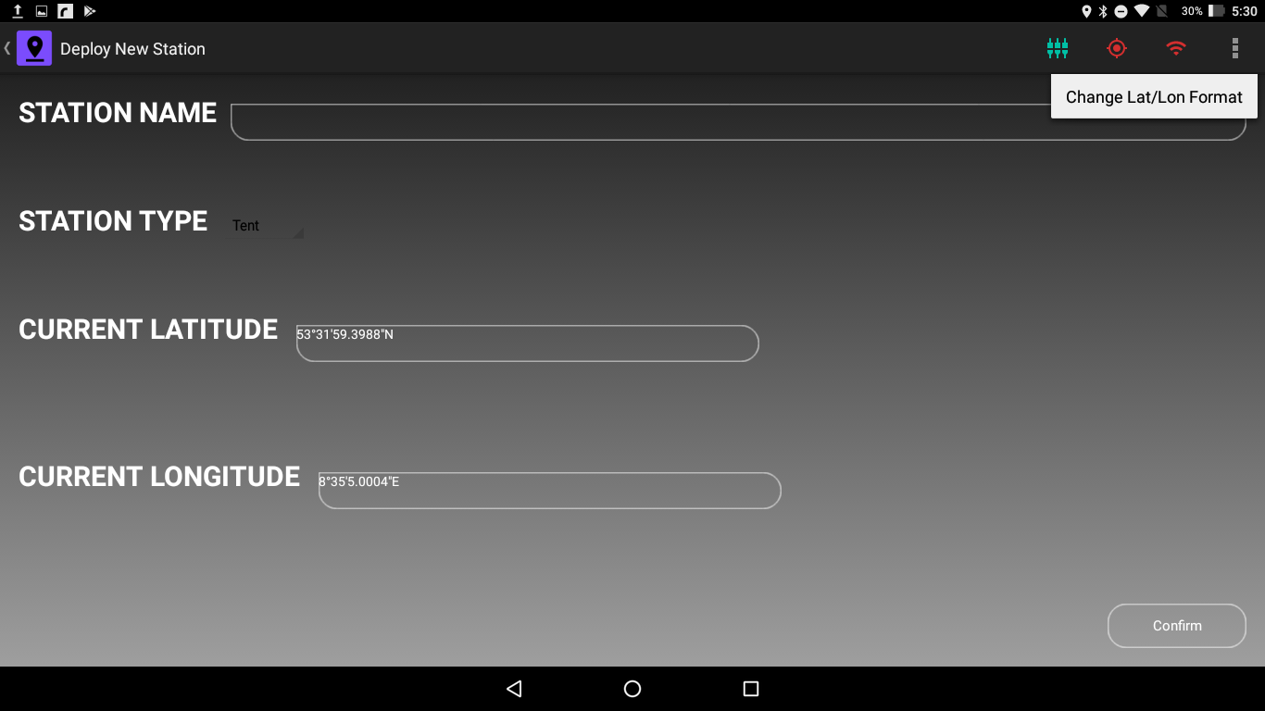

Figure 4.3 Chane Lat/Lon Format Button in the Status Bar

To set the station type tap on the Station Type field which will show the type of stations which can be installed.

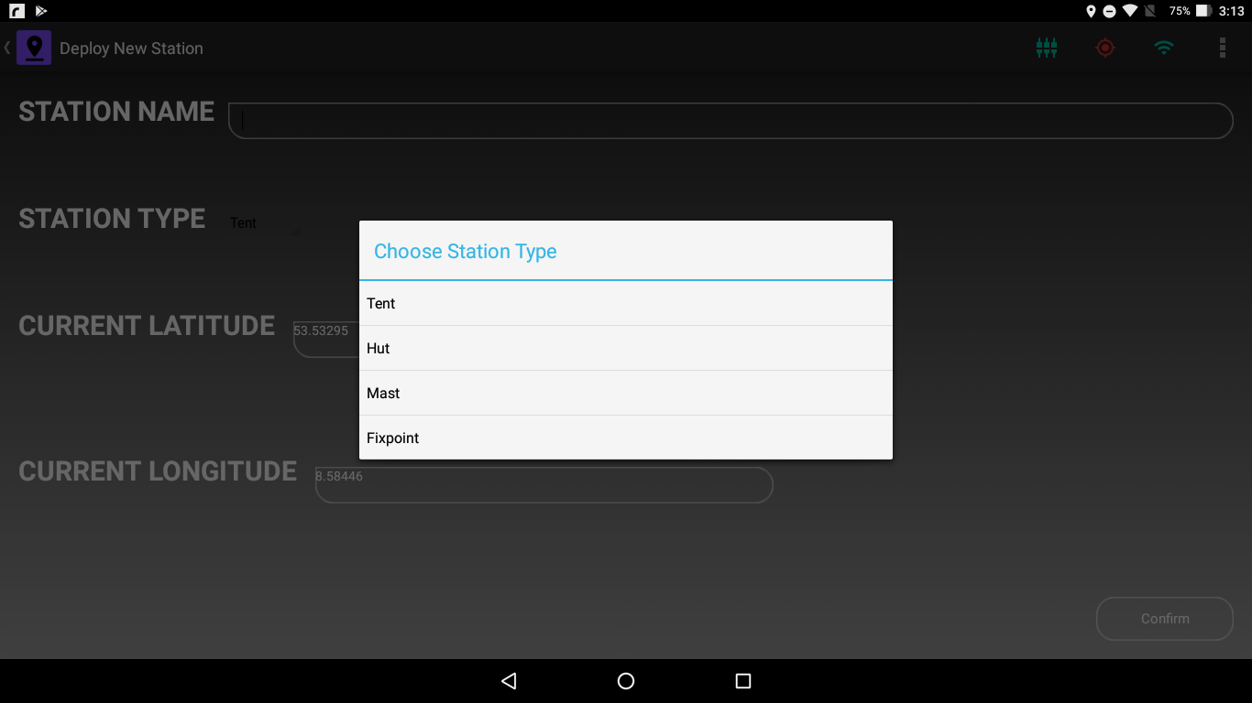

Figure 4.4 Static Station Types

Pressing the Confirm button at the bottom right of the screen will install the new Static Station. If location is not available and the Confirm button is pressed, the App will not deploy the static station and will show an error message. When the tablet location is available, Station Name and Type are correctly set and then Confirm button is pressed, the App will calculate the {x, y} coordinates from the tablet location and install a Static Station at those coordinates.

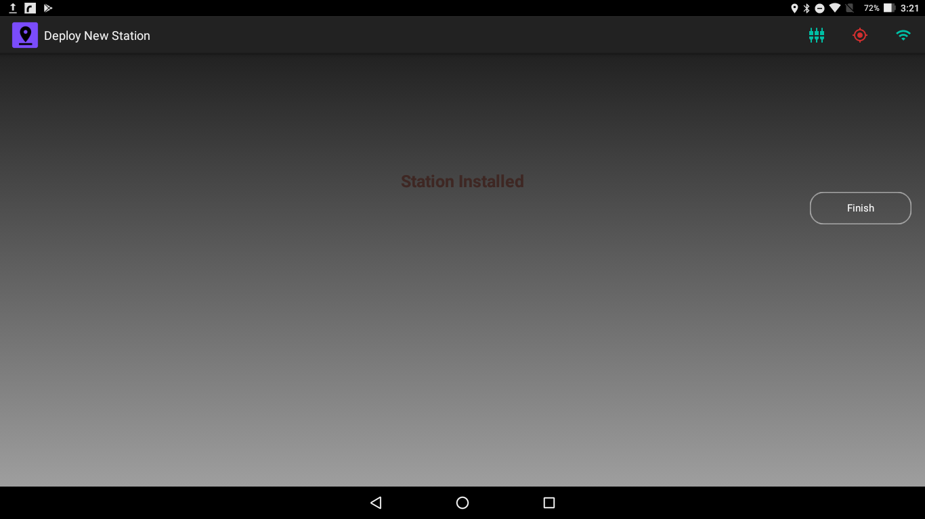

Figure 4.5 Successful Deployment of a Static Station

Pressing the Finish button will take you back to the Main Dashboard.

# Waypoint

This Chapter describes the installation of Waypoints in the Floe Navigation System.

Waypoints are marked points of interest on the Sea Ice. Waypoints can be used to specify points along a track on the ice, or a single point where measurement can be taken in the future or it can also be used to marked danger zones or sensitive spots on the ice. Waypoints do not have an AIS data and hence are not used by the App to maintain the coordinate system. Each Static Station is identified by a label. The label of the Waypoint is appended with the Tablet’s unique identifier to make it unique across the Floe Navigation System. The Waypoint label is stored internally along with a time stamp and the {x, y} coordinates.

You can install a new Waypoint by tapping on the Waypoint button on the Main Dashboard which opens the Waypoint screen. Unlike Static Stations you (the user) can delete the Waypoints.

You should specify a unique label for each Waypoint. The App deploys a waypoint at the current location of the tablet which is available via GPS. The Waypoint screen shows the current location of the tablet in the current Latitude and Longitude fields of the screen. The software is designed in such a way that the latitude and the longitude fields will be automatically updated when you move with the tablet. If the location is not available the current Latitude and Longitude Fields will be set to 0.00.

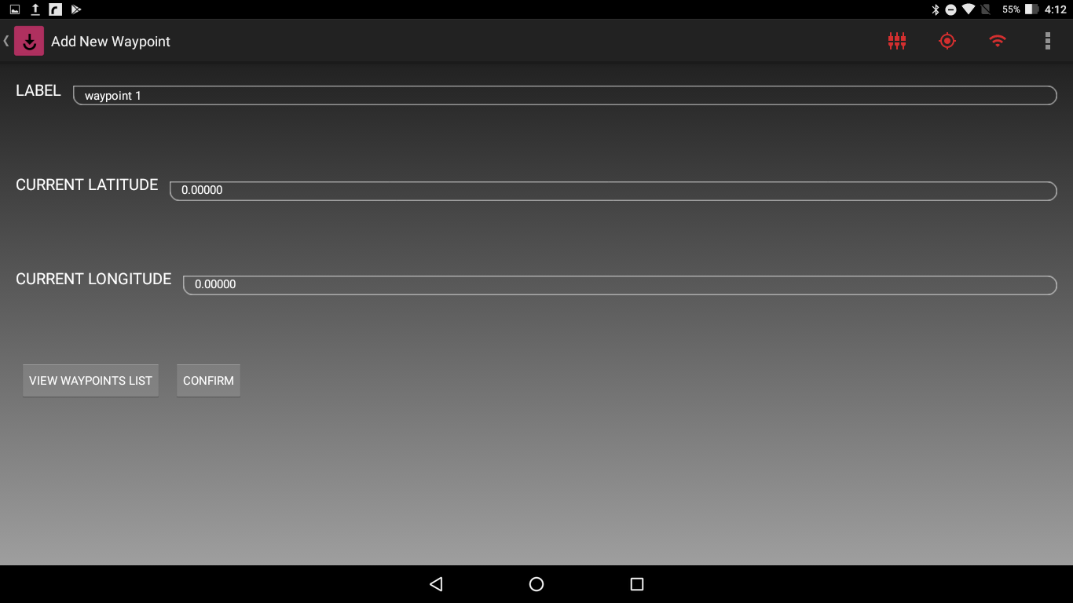

Figure 5.1 Waypoint Installation when Tablet Location is unavailable

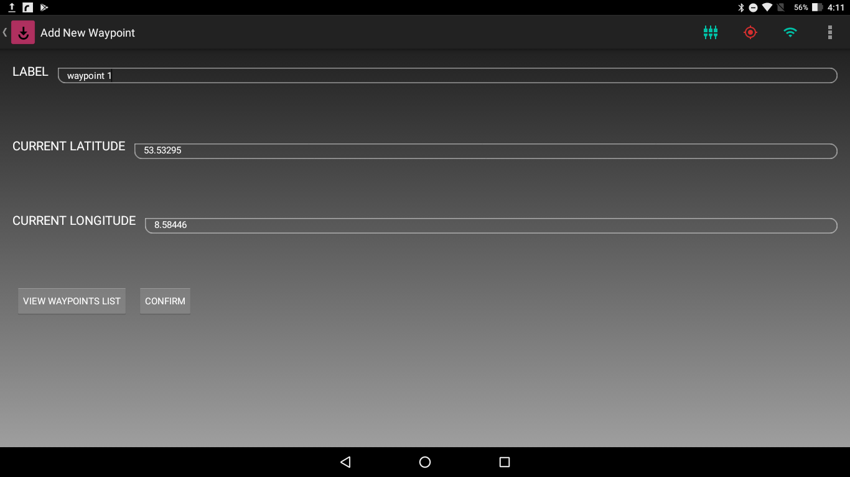

Figure 5.2 Waypoint Installation when Tablet Location is available

Just as in the Deployment screen there is a Change Lat/Lon Format button in the Status bar to change the format of the displayed coordinates.

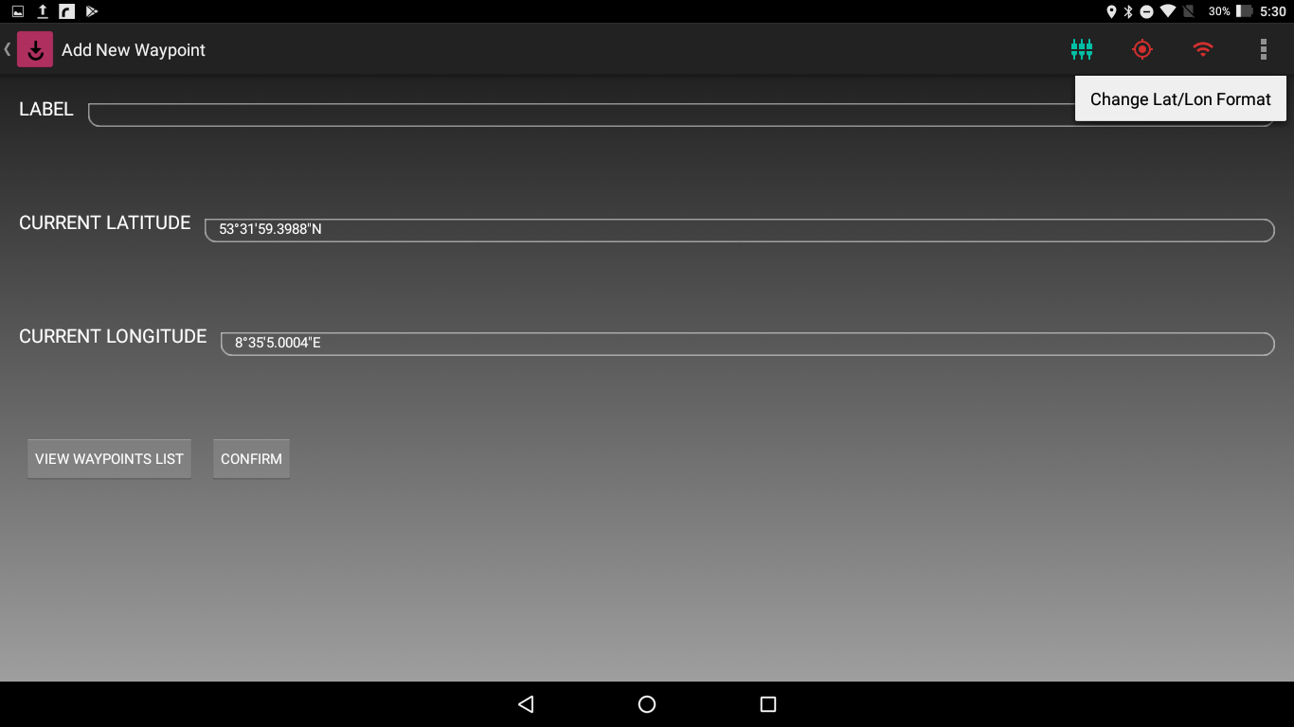

Figure 5.3 Change Lat/Lon Format Button in the Status Bar

Pressing the Confirm button at the bottom of the Waypoint installation screen will install a new Waypoint. If location is not available and the Confirm button is pressed, the App will not install a waypoint and will show an error message. When the tablet location is available, Waypoint label and Type are correctly set and then Confirm button is pressed, the App will calculate the {x, y} coordinates from the tablet location, create a Time Stamp in UTC, and install a Waypoint at those coordinates.

Pressing the Finish Button will take you back to the Main Dashboard.

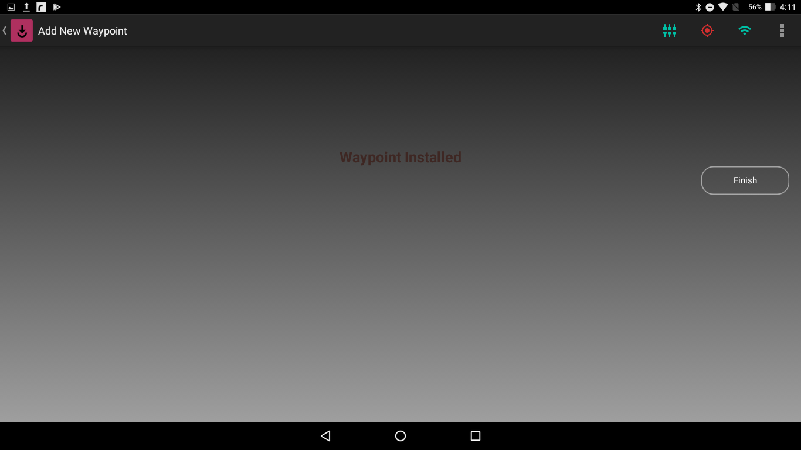

Figure 5.4 Successful Installation of a Waypoint

You can view the all the waypoints installed in the Floe Navigation system by tapping on the *View Waypoints List* button at the bottom left of the screen. This will show all the Waypoints that have been installed on that tablet and waypoints that have been installed on other tablets, provided the App has been synchronized with the Floe Navigation Sync Server. For details check Floe Navigation Administrator Guide. The Waypoint list will show all the waypoint labels, appended with the Unique device ID and their respective {x, y} coordinates.

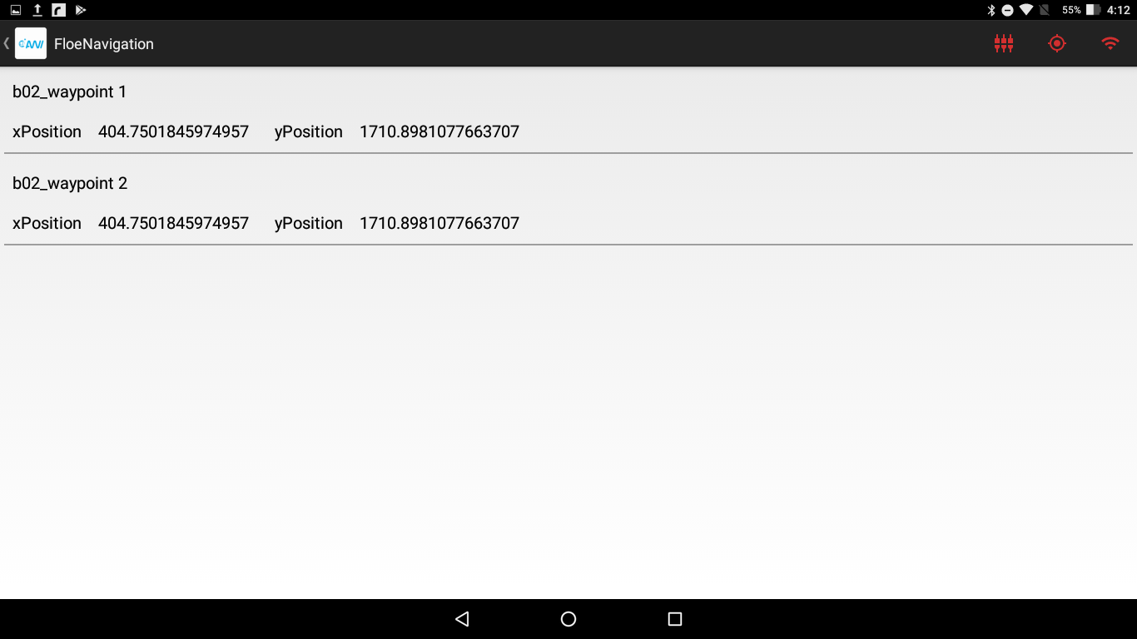

Figure 5.5 List of all Waypoints Installed

In order to Delete a Waypoint, simply swipe right on that waypoint and the waypoint will be deleted. (Please keep in mind that the deletion of the Waypoint will not be reflected in other tablets by default and it will be deleted in other tablets after Synchronization with the Floe Navigation Sync Server. For Details see Floe Navigation Administrator Guide).

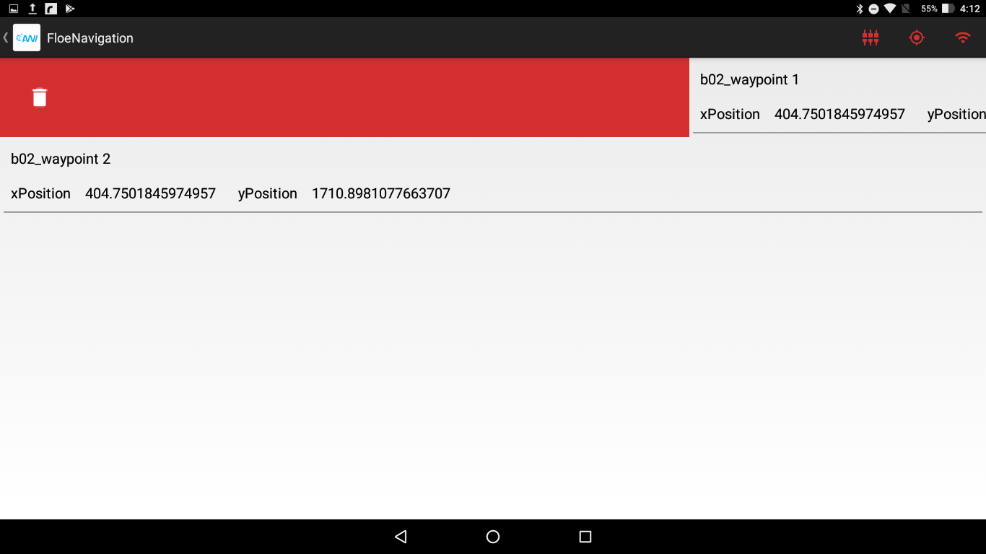

Figure 5.6 Deletion of Waypoint

# Sample/Measurement

This Chapter describes taking Sample/Measurement with the Floe Navigation System.

The Floe Navigation System can also be used to manage Samples which are taken on the Sea Ice. For each sample it can store the device details with which the sample was taken, whether it was a sample or a measurement, and the location data along with the timestamp and a free text label. The details of all the sample stored in the system are available on the Floe Navigation Sync Server. The location data stored contains the Latitude, Longitude (Geographic Coordinates) at the time the sample was taken and the local {x, y} Coordinates.

To use the Sample/Measurement section of the Floe Navigation App you must first import devices in to it. By default, the Floe Navigation App does not contain any devices and it will only import new devices from the Floe Navigation Sync Server during Synchronization. For details see Floe Navigation Administration Guide. If there are no devices in the Floe Navigation App the Sample/Measurement section of the App is disabled.

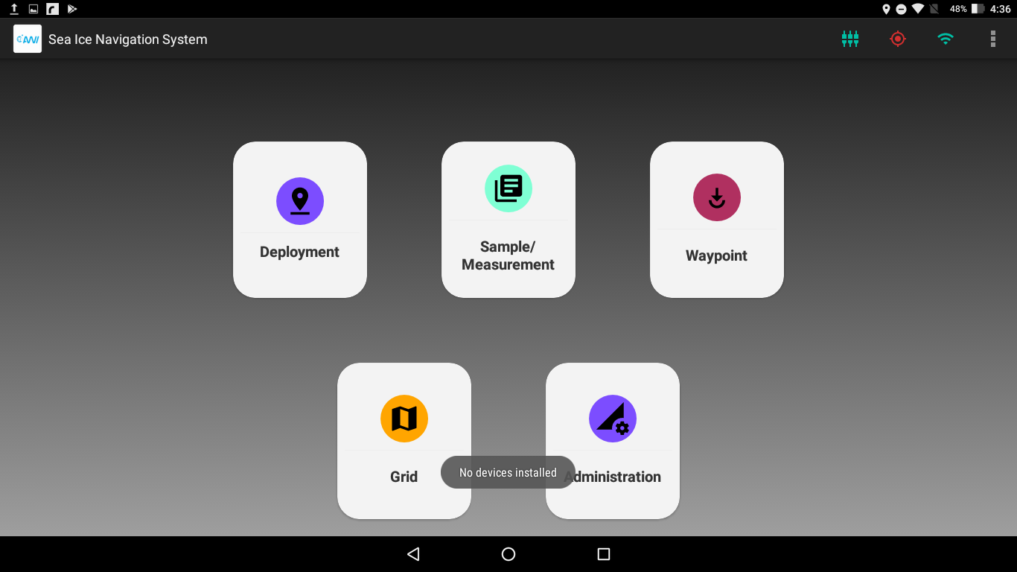

Figure 6.1 Sample/Measurement is disabled when no devices are imported

Once devices have been imported from the Floe Navigation Sync Server, you can create a new Sample/Measurement by tapping on the Sample/Measurement button on the Main Dashboard which opens the Sample/Measurement screen.

You should select the operation being performed whether it is a sample or a measurement. A free text label field available to store further details.

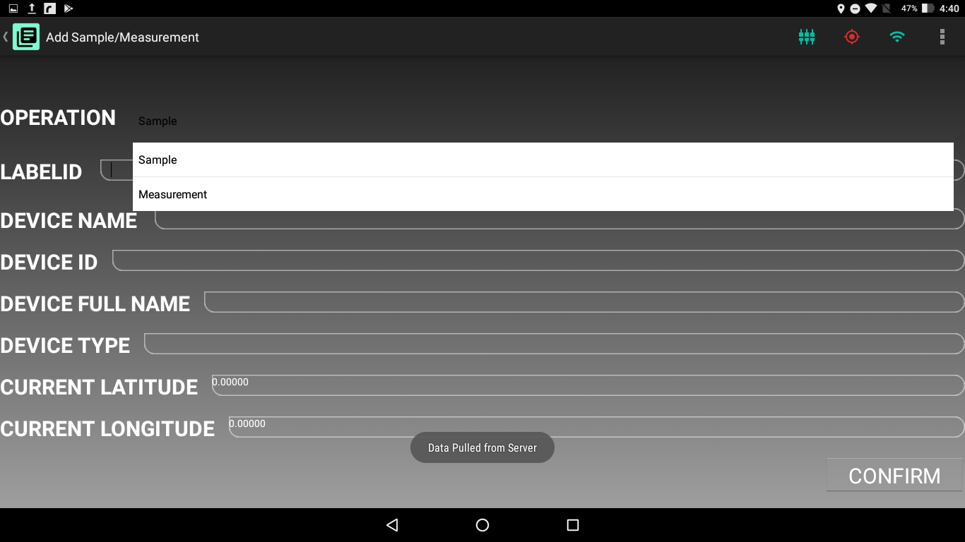

Figure 6.2 Operations Available in Sample/Measurement

Tapping on the Device Name field will show all the available devices in the app and as you type in the field the app filters the Device List to only show matching devices.

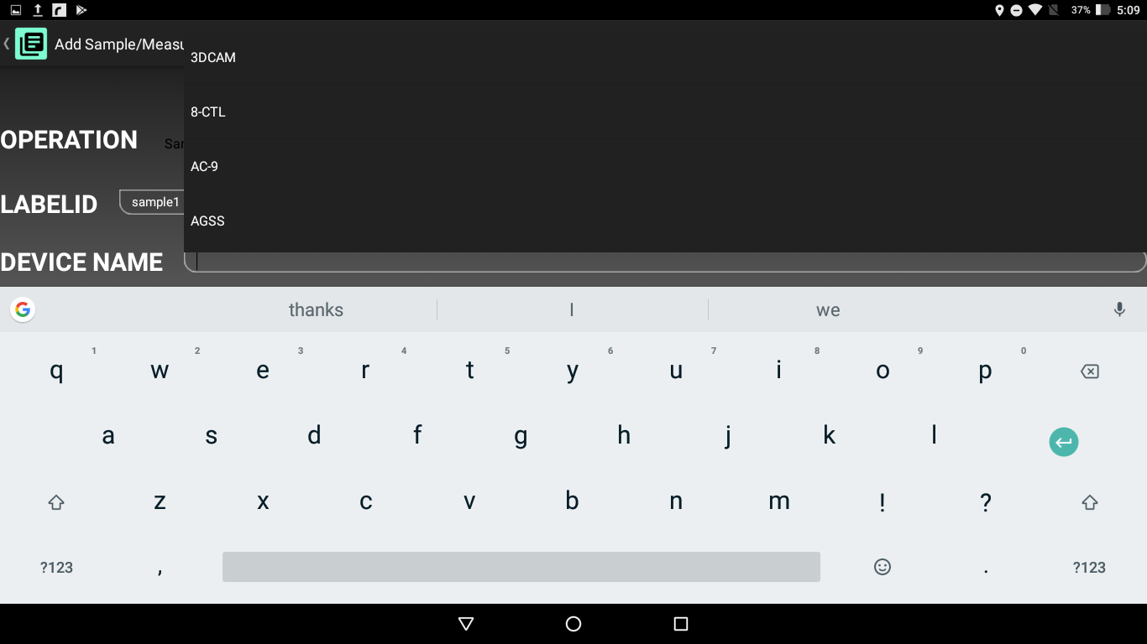

Figure 6.3 Tapping on the Device Name shows the Complete Device List

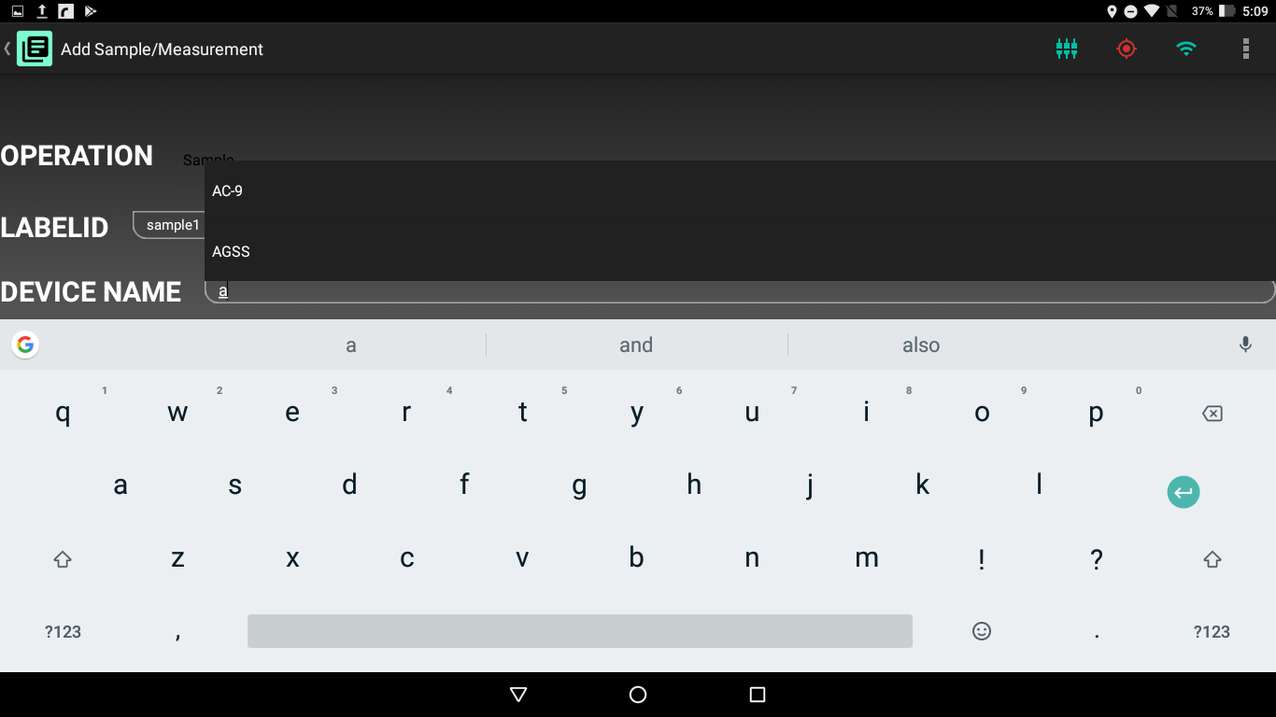

Figure 6.4 Devices are filtered when you start typing Device Name

Once you select a device the other device related details are filled automatically.

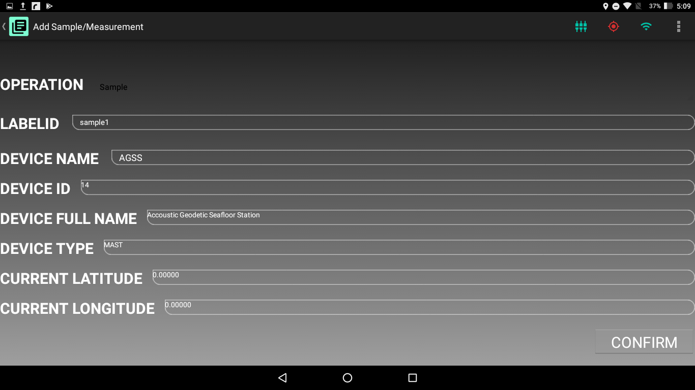

Figure 6.5 Device Details are automatically filled when a Device is selected

Similar to Waypoints and Static Stations it is not possible to take Sample/Measurement when the tablet location is not available via GPS.

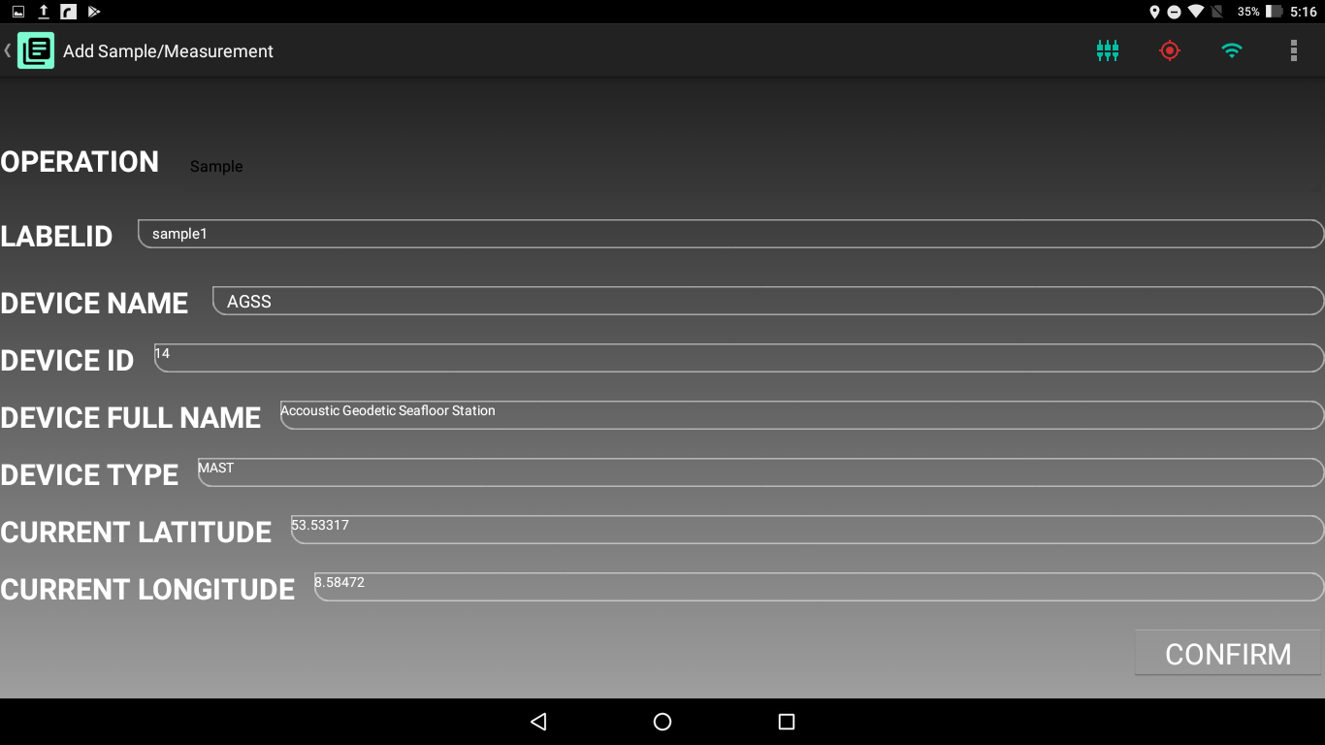

Figure 6.6 Taking a Sample when Device Location is Available

Just as in Waypoint and Deployment screens there is a Change Lat/Lon Format button in the Status bar to change the format of the displayed coordinates.

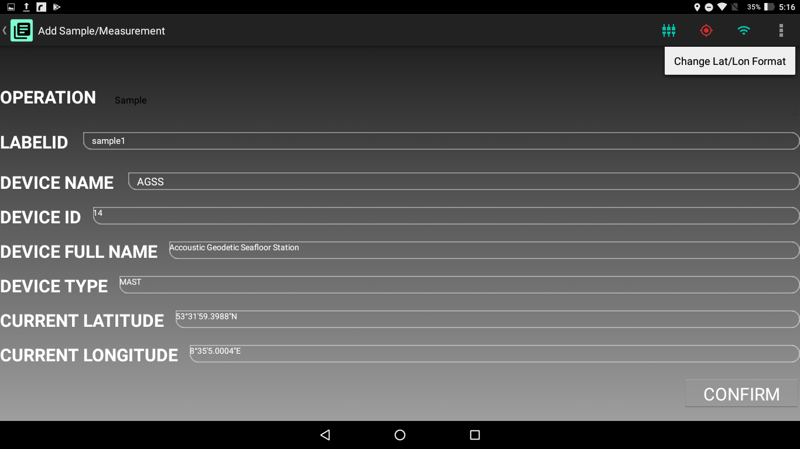

Figure 6.7 Change Lat/Lon Format button in Status Bar

When the tablet location is available, the label is filled and device details are correctly set and then Confirm button is pressed, the App will calculate the {x, y} coordinates from the tablet location, create a Time Stamp in UTC, and store a Sample/Measurement with those coordinates in its local Database and the Main Dashboard is opened.